## Morphometrics data lab 1

* Identify 3 traits to measure on your organism; Decide on appropriate units and justify your decision.
* Collect 30 observations for each trait and record them on an excel spreadsheet. Remember to enter traits (variable) as columns and observations as rows

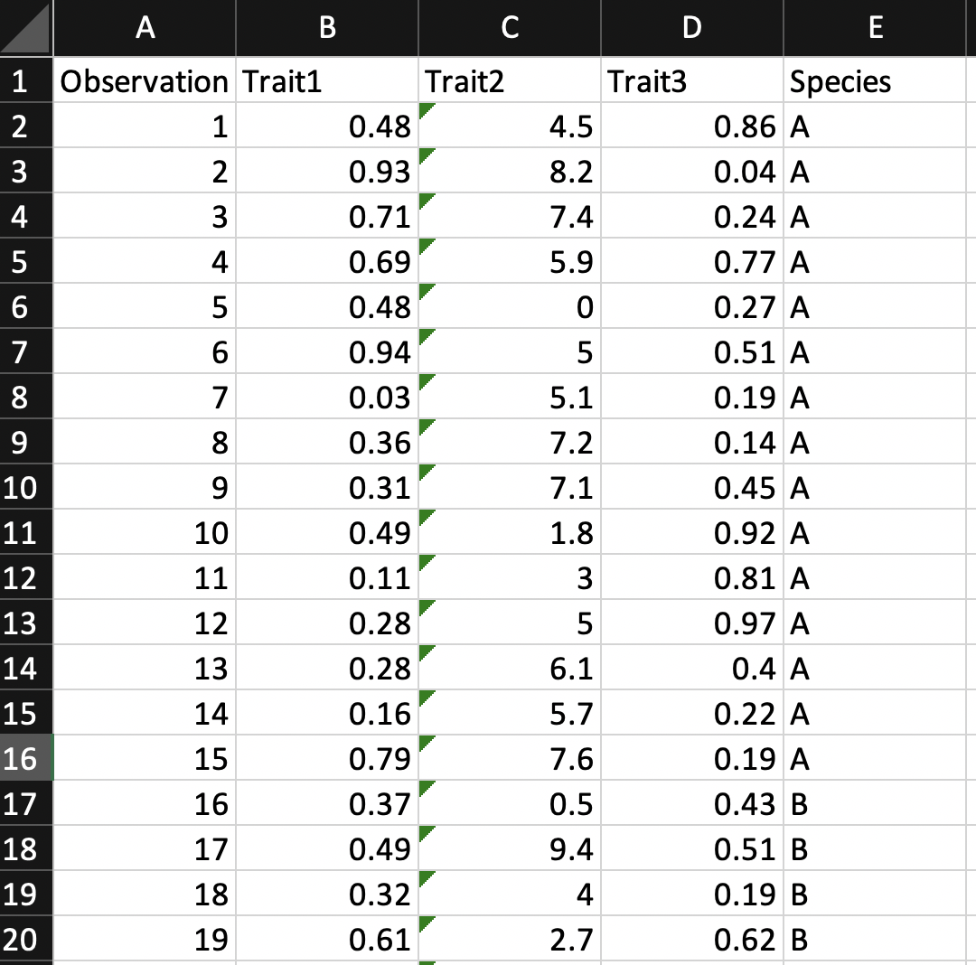

* Develop a metadata sheet for the traits that you have measured

In a separate excel sheet create a metadata file with the first column titled variable name and the second column as much definition of the variable as possible: (e.g. units of measurement, equipment used, source of the specimens)

* Calculate the mean, sample variance and standard deviation of each trait. Use the `AVERAGE`, `STDEV` and `VAR.S` functions in excel.

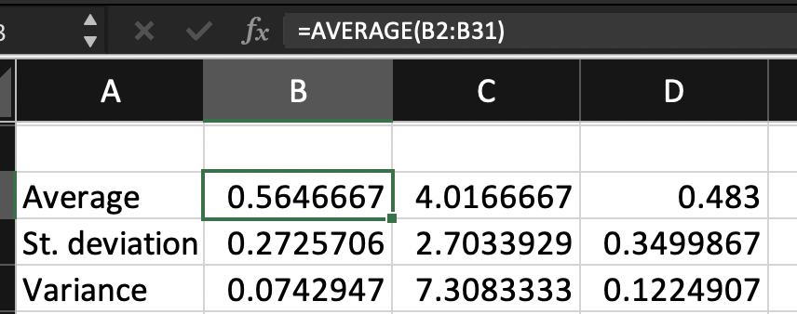

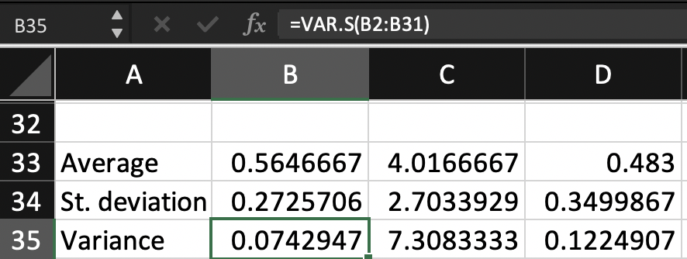

* Create a histogram of each trait. What happens when you modify the bin size?

